SDG4: Quality Education

**Course Title: Achieving Quality Education for All (SDG 4)**

**Unit 1: Understanding the Global Education Landscape**

**Key Topics:**

* Lesson1: Overview of SDG 4 and its importance for sustainable development.
  + <https://youtu.be/dKip3rpuEvY?si=0Sd3yTs-WOelnRi_>
* Lesson2: Global education statistics: literacy rates, access to education, and gender disparities.
  + Study this: 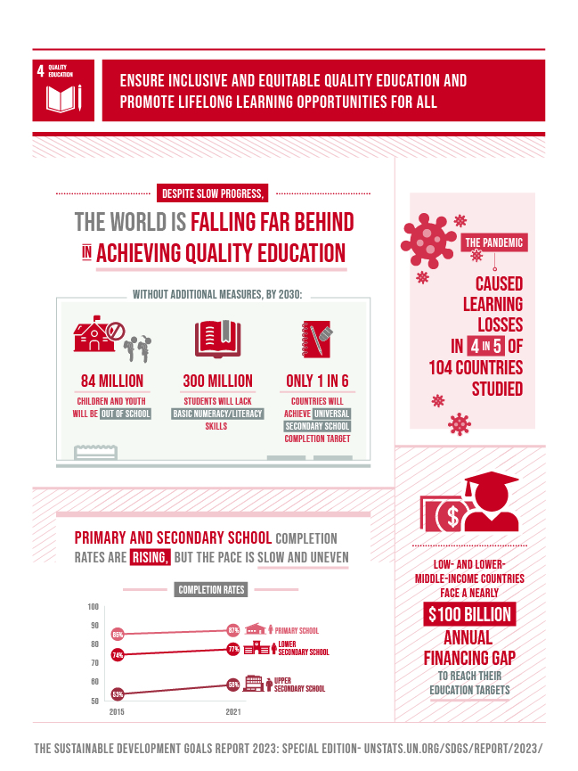
* Lesson3: Barriers to education: poverty, conflict, gender inequality, and location (rural vs urban).
  + <https://youtu.be/wHNUx0w4L8s?si=F3EmKotrFEHaN4KH>

**Activity:**

* **Interactive Map**: Use global data to compare literacy rates and school enrollment between developed and developing countries.
  + <https://sdgstoday.org/dataset/my-school-today>

**Assessment:**

* **Quiz**: Test students on global education statistics and key concepts covered in the unit.

**1.** What is the main objective of SDG 4?

* A) To promote economic growth globally
* B) To ensure inclusive and equitable quality education for all
* C) To reduce global inequality
* D) To improve healthcare access for all

**Answer**: B) To ensure inclusive and equitable quality education for all

**2.** Which of the following is a major barrier to achieving quality education in developing countries?

* A) Urbanization
* B) High literacy rates
* C) Gender inequality
* D) Population growth

**Answer**: C) Gender inequality

**3.** What global statistic is used to measure access to education?

* A) Poverty rate
* B) Literacy rate
* C) Employment rate
* D) Birth rate

**Answer**: B) Literacy rate

**4.** Which region faces the highest levels of educational disparity due to conflict and poverty?

* A) North America
* B) Europe
* C) Sub-Saharan Africa
* D) East Asia

**Answer**: C) Sub-Saharan Africa

**5.** Which SDG is most closely related to the achievement of SDG 4?

* A) SDG 3 (Good Health and Well-being)
* B) SDG 6 (Clean Water and Sanitation)
* C) SDG 8 (Decent Work and Economic Growth)
* D) All of the above

**Answer**: D) All of the above

* **Reflection**: Short writing assignment on how education impacts other SDGs, such as poverty reduction and gender equality.

اعمل هنا text box للإجابة علي السؤال

**Unit 2: Education in Egypt and the Middle East**

**Key Topics:**

* Lesson1: Overview of Egypt's education system: access, quality, and regional disparities.
  + <https://youtu.be/54LUCEHM5eA?si=-vym5BvdgO6uN4Du>
* Egypt Vision 2030 and its alignment with SDG 4.

Article: **Egypt Vision 2030 and Its Alignment with SDG 4: Quality Education**

Egypt’s Vision 2030, launched in 2016 and updated in 2022, reflects the nation's commitment to sustainable development across economic, social, and environmental dimensions. One of the core components of Egypt’s Vision 2030 is its alignment with the United Nations Sustainable Development Goals (SDGs), particularly SDG 4, which focuses on ensuring inclusive and equitable quality education and promoting lifelong learning opportunities for all.

**Egypt Vision 2030 and Education**

Education is at the heart of Egypt Vision 2030’s framework, as improving the quality of education is seen as essential to achieving the broader developmental goals of the nation. Egypt’s vision aims to develop a competitive and innovative economy, heavily reliant on knowledge and human capital. Therefore, the focus on education is aimed at creating a more knowledgeable workforce, enhancing innovation, and ensuring that every Egyptian has access to quality education.

**Key Aspects of Alignment with SDG 4:**

1. **Inclusive Education for All**: SDG 4 emphasizes inclusive and equitable education for all individuals, including marginalized groups. Egypt Vision 2030 aligns with this by promoting social justice and equality in educational opportunities, ensuring that all citizens, regardless of their gender, disability, or socioeconomic background, have access to education.
2. **Quality of Education**: Improving the quality of education is a crucial aspect of both Egypt Vision 2030 and SDG 4. Egypt’s strategy outlines goals to enhance the curriculum, integrate technology, and improve teacher training programs to ensure that students receive a world-class education that equips them with the skills necessary for the modern workforce.
3. **Lifelong Learning Opportunities**: SDG 4 emphasizes the importance of lifelong learning. Egypt’s Vision 2030 includes plans to promote continuous learning through vocational training, adult education programs, and online platforms to equip citizens with skills relevant to a fast-evolving job market.
4. **Technological Integration in Education**: A vital enabler identified in Egypt Vision 2030 is the integration of digital tools and innovation in education, which is also highlighted under SDG 4. Egypt’s commitment to increasing technological access within the education sector ensures that students can benefit from modern learning resources, expanding the reach of education to remote and underserved areas​(egypt2030).

**Goals and Objectives**

Egypt’s Vision 2030 also seeks to expand its education system to meet future challenges, such as rapid population growth and the increasing demand for a skilled labor force. The plan highlights key objectives, such as:

* Increasing enrollment rates at all levels of education.
* Enhancing the quality and accessibility of technical and vocational education and training (TVET) programs.
* Promoting research, innovation, and higher education institutions as engines of knowledge production and development.

**Challenges and Solutions**

One of the major challenges for both Egypt’s Vision 2030 and SDG 4 is ensuring equitable access to quality education across the country, particularly in rural areas. The vision addresses this through policies aimed at reducing regional disparities in educational resources and improving infrastructure in underserved areas.

Additionally, the vision emphasizes the importance of partnerships between the government, the private sector, and civil society to help fund and sustain educational reforms​(egypt2030).

**Conclusion**

Egypt’s Vision 2030 is strongly aligned with the principles of SDG 4, as it recognizes the critical role education plays in building a sustainable future. By focusing on inclusivity, quality, and lifelong learning, the vision aims to create a resilient, knowledge-based economy that empowers all citizens to participate in the nation's growth.

* Lesson3: Case studies from Egypt and the Middle East: efforts to improve education in rural areas, girls' education, and access to technology in schools.
  + <https://youtu.be/fqDpl0UwcI8?si=uMLj0eVMOVdGEbgk>

**Activity:**

* **Research**: Investigate how educational reforms in Egypt, such as curriculum changes or technology integration, are advancing SDG 4.
  + **اعمل مكان هنا يرفع فيه البحث بتاعه**

**Assessment:**

* **Quiz**:

**1.** What is the key focus of Egypt's Vision 2030 in relation to education?

* A) Increasing access to higher education
* B) Aligning the education system with sustainable development goals
* C) Privatizing public schools
* D) Eliminating free education

**Answer**: B) Aligning the education system with sustainable development goals

**2.** Which of the following is a major challenge in Egypt’s education system?

* A) Over-enrollment in rural areas
* B) Lack of gender disparity in schools
* C) Unequal access to education in rural versus urban areas
* D) High literacy rates

**Answer**: C) Unequal access to education in rural versus urban areas

**3.** How is Egypt working to improve the quality of education in alignment with SDG 4?

* A) By closing rural schools
* B) By increasing the use of technology and digital tools in classrooms
* C) By limiting access to higher education
* D) By increasing tuition fees for public schools

**Answer**: B) By increasing the use of technology and digital tools in classrooms

**4.** What is one key challenge faced by girls in rural areas of the Middle East when it comes to accessing education?

* A) Language barriers
* B) Lack of infrastructure
* C) Cultural norms that prioritize boys' education
* D) Overcrowded schools

**Answer**: C) Cultural norms that prioritize boys' education

**5.** Which Middle Eastern country has made significant progress in improving girls' access to education?

* A) Yemen
* B) Lebanon
* C) Syria
* D) Afghanistan

**Answer**: B) Lebanon

**Unit 3: Innovations in Education for the 21st Century**

**Key Topics:**

* Lesson1: The role of technology in modern education: e-learning platforms, digital literacy, and mobile education.
  + <https://youtu.be/LcGhaFtsmoo?si=bhpRo3LNBnDdNmHJ>
* Lesson2: Innovations in education: artificial intelligence, virtual classrooms, and online learning.
  + <https://youtu.be/_x5wo9erObM?si=x4E0q69Yxf3ck520>
* Lesson3: Lifelong learning and skills development for the future workforce.
  + <https://youtu.be/lV6pMObHVLA?si=ALKGIp9YlBGYGvcI>

**Assessment:**

**1.** What is one of the most important innovations that have expanded access to education globally?

* A) Textbooks
* B) Online learning platforms
* C) Traditional classrooms
* D) Paper-based exams

**Answer**: B) Online learning platforms

**2.** How can artificial intelligence (AI) contribute to education innovation?

* A) By replacing teachers in classrooms
* B) By personalizing learning for individual students
* C) By reducing access to higher education
* D) By automating all educational processes

**Answer**: B) By personalizing learning for individual students

**3.** Which technology is increasingly used to provide remote learning opportunities in rural or underserved areas?

* A) Virtual Reality (VR)
* B) Mobile applications
* C) 3D printing
* D) Robotics

**Answer**: B) Mobile applications

**4.** What is a primary benefit of e-learning platforms in advancing SDG 4?

* A) They are expensive to implement
* B) They offer flexible and scalable education for students everywhere
* C) They can only be used in cities
* D) They limit access to certain subjects

**Answer**: B) They offer flexible and scalable education for students everywhere

**5.** Which of the following is an example of lifelong learning?

* A) Taking a break from school after high school
* B) Enrolling in a skills development program after completing formal education
* C) Dropping out of high school to start working
* D) Limiting education to primary school

**Answer**: B) Enrolling in a skills development program after completing formal education

**Unit 4: Achieving Inclusive and Equitable Education**

**Key Topics:**

* Lesson1: The significance of inclusive education: addressing the needs of marginalized groups, including girls, children with disabilities, and refugees.
  + <https://youtu.be/ZIPsPRaZP6M?si=HWUx6MW6vktZ5460>
* Lesson2: Policies and programs that promote equity in education (e.g., school feeding programs, scholarships, and inclusive curriculum).
  + Read: <https://www.aucegypt.edu/admissions/scholarships/USAIDscholars>
* Lesson3: Global examples of inclusive education initiatives.
  + <https://youtu.be/8HPh4RoV63s?si=zSRL6QeHv9og-5Oq>

**Activity:**

* <https://learn.arcgis.com/en/paths/sdg-4-quality-education/>

**Assessment:**

1. What is the primary focus of inclusive education?

A) Reducing the cost of education

B) Ensuring that all children, regardless of background, have access to quality education

C) Teaching only advanced students

D) Limiting education to urban areas

Answer: B) Ensuring that all children, regardless of background, have access to quality education

2. Which group is most likely to face barriers to accessing education?

A) Urban youth

B) Girls in rural areas

C) Boys in cities

D) Adults over 40

Answer: B) Girls in rural areas

3. What is a key policy approach to promoting inclusive education for students with disabilities?

A) Segregating students with disabilities

B) Providing special education teachers and resources in mainstream schools

C) Limiting their access to formal education

D) Placing all students in separate schools

Answer: B) Providing special education teachers and resources in mainstream schools

4. Which of the following can help improve access to education for refugees?

A) Reducing the number of schools available

B) Offering education programs in refugee camps

C) Excluding them from local education systems

D) Limiting their access to basic education

Answer: B) Offering education programs in refugee camps

5. Which international organization works extensively on promoting inclusive education globally?

A) United Nations Educational, Scientific and Cultural Organization (UNESCO)

B) World Health Organization (WHO)

C) International Monetary Fund (IMF)

D) Greenpeace

Answer: A) United Nations Educational, Scientific and Cultural Organization (UNESCO)